Business Rule Implementation Procedure

Procedure:

Define New Business Rules.

- Define Business Rule
- Define Business Rule Set
- Define Business Rule Link

- We can define our own business rules by creating and loading XML files.
- Below is the xml file in which the Business Rule was defined.
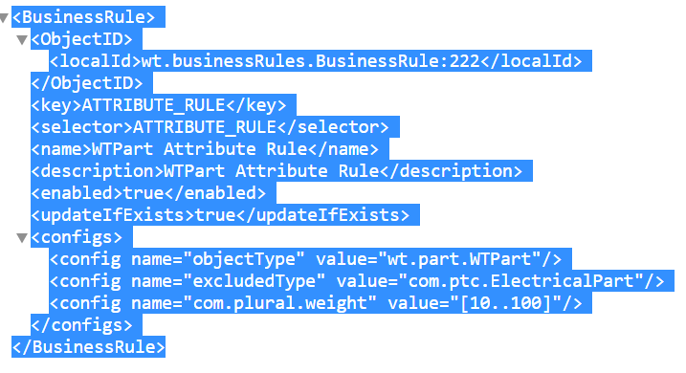

- Below is the xml file in which the Business Rule Set was defined.
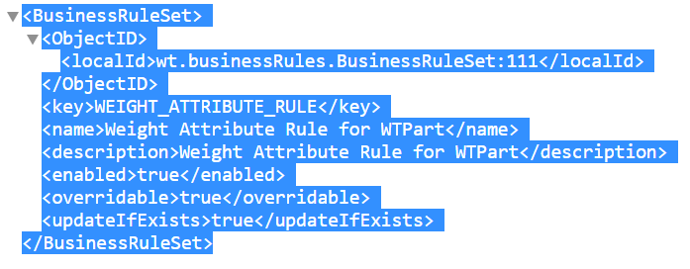

- Below is the xml file in which the Business Rule Link was defined.
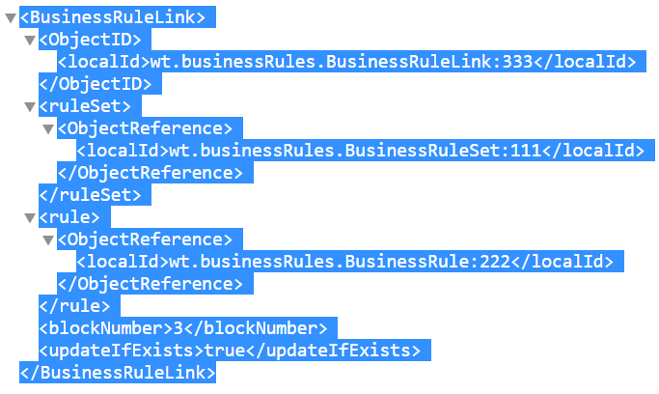

Loading Business Rules Objects

- Add the load files to a zip file. For example, add the AttributeRule in a zip file such as:

<windchill>/loadFiles/ixbImport/AttributeRule.zip

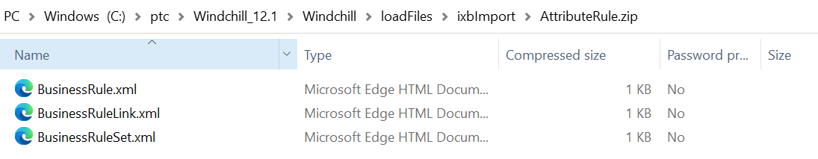

- Create the XML load file to load the generated zip file created in step 1.
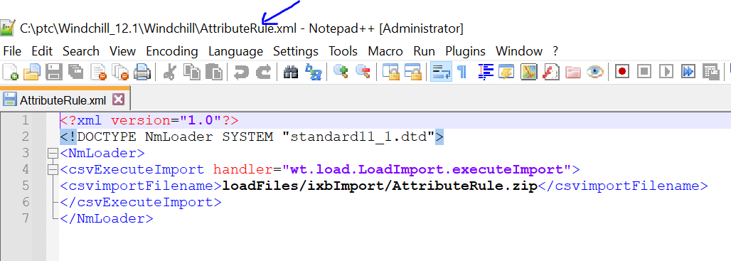

- Using a windchill shell, execute the following load command to load the business rules objects.

windchill wt.load.LoadFromFile -d <PATH>\loadFileName

Calling the Business Rules Engine

- Update the workflow to call the Business Rule as shown below.
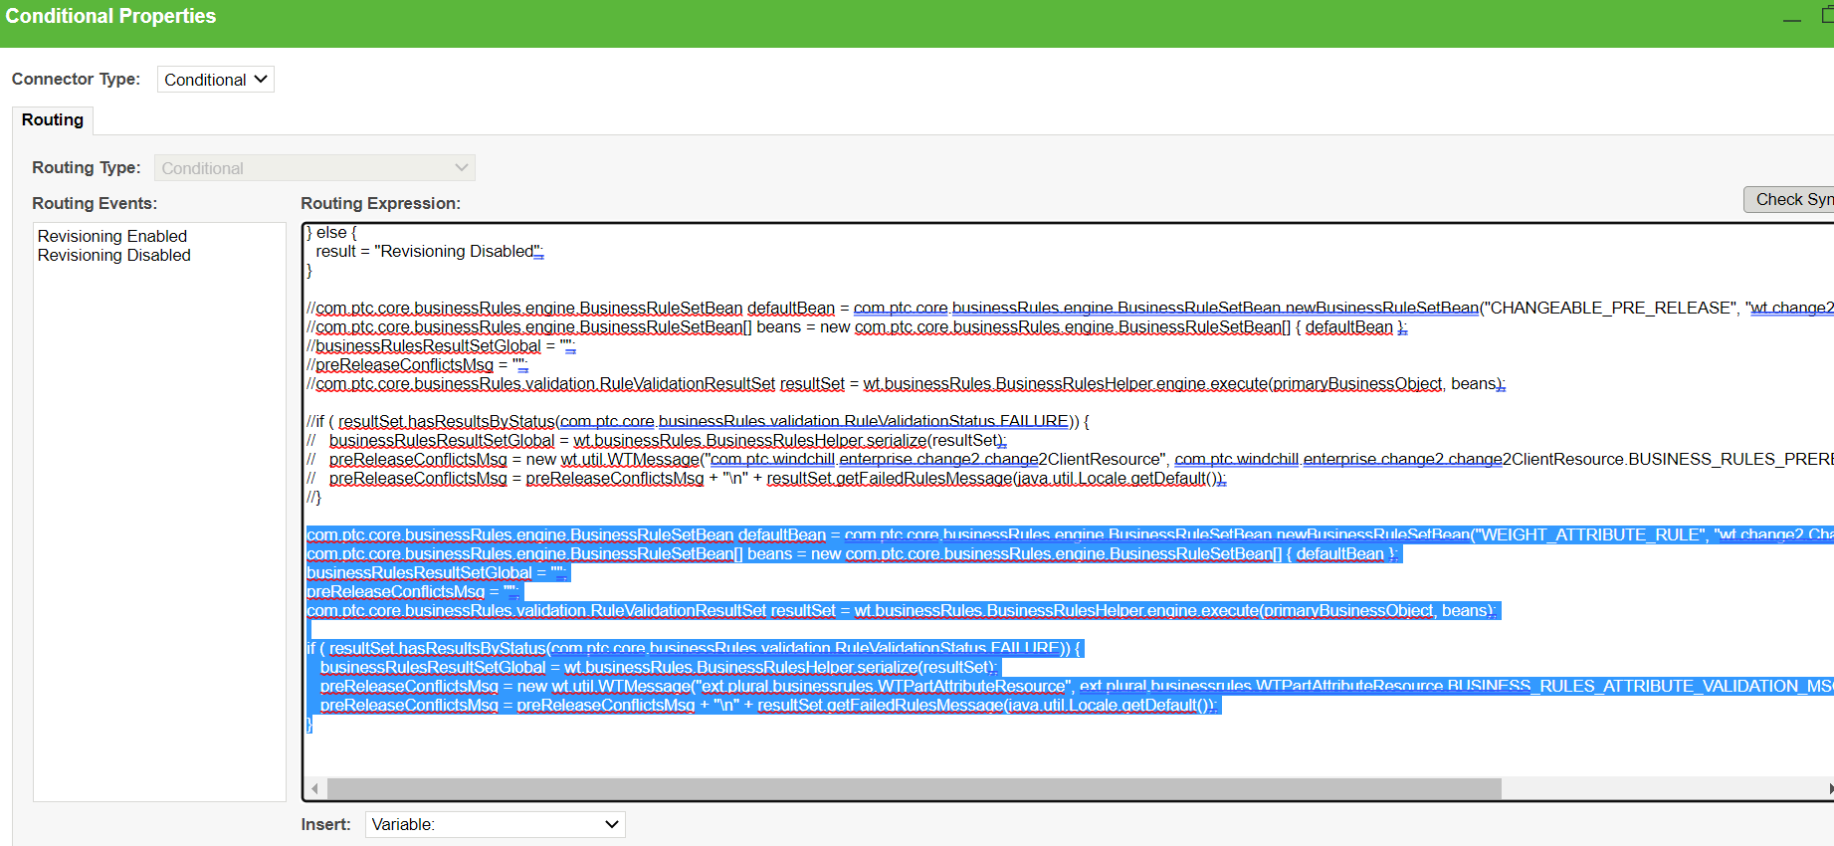

- Save the changes and check in workflow.

